**Sapwood Ventures**

**Human Capital Consultants**

***Assignment from Alpha Care***

DJANGO + REACTJS Assignment for Alpha Health

**This documents discusses the overview on the provided assignment. Project Level insights are documented as per the given requirement.**

***Author*** *: MALLIKARJUN J, Full-Stack Web Developer*[*mallikarjunj28@gmail.com*](mailto:mallikarjunj28@gmail.com) *9986181653*

Contents

Background: 3

Features of this project: 3

Solution Architecture: 3

Overview: 3

Database structure: 4

Project Folder Structure: 5

Launching the server: 6

Project URL: 6

Admin Details: 6

Credentials : 6

# Background:

The assignment is about creating WebApp for Alpha Health. The requirement is to build a dynamic website that uses Python’s Django web framework as the backend system and JavaScripts ReactJS library for the front-end.

In this Project I’ve used the Django web framework for the backend with HTML and JavaScript/jQuery for making the interactive frontend.

The project meets majority of the requirement covering the backend and front end sides.

# Features of this project:

Create/View/Update for end users(Patients)  
Create/View/Update for appointments  
This architecture is based on the JSON API.  
Dynamic webpages built using AJAX and jQuery.

# Solution Architecture:

## Overview:

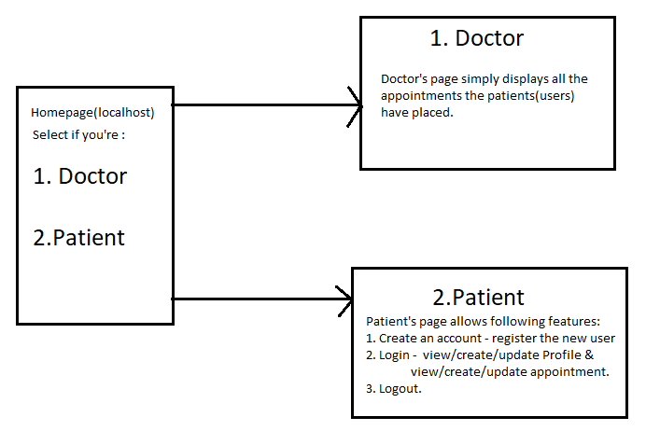

# Database structure:

|  |  |
| --- | --- |
| **Description** | **Database structure** |
| For this project, there are 3 tables utilised:  AlphaHealthApp_**users :** This table stores the list of all users for login purpose.  AlphaHealthApp_**userappointments:**  This table holds the list of appointments which every user/patient may input and register. This table is viewed by Doctor profile as well.  AlphaHealthApp_**usersinfo:**  Constains basic patients details as shown the table.  Please note the userName columns is considered as the Primary Key. |  |

# Project Folder Structure:

|  |  |
| --- | --- |
| **Description** | **Project File structure** |
| The image on the right side of the table shows the Django folder structure.   * ah_env: Virtual environment * AlphaHealthProject: is the Django project directory. * AlphaHealthApp: is the Django App within the Django Project directory – AlphaHealthProject. |  |

# Launching the server:

Assuming python and virtual environment are installed, below are the steps to start and run the server.

1. Activate the virtual environment - ah_env using the command prompt:

**ah_env\Scripts\activate**

1. start the server using the command : **python manage.py runserver**
2. You can start using the browser and entering the URL as mentioned in next step.

# Project URL:

Please enter the localhost url post server is initiated.  
 URL : <http://127.0.0.1:8000/>

This should start the server and display the homepage.

# Admin Details:

I’m utilizing Django’s built-in administrator functionality:  
Admin page :-   
URL : http://127.0.0.1:8000/admin/

## Credentials:

Username : admin  
Password : admin

